Write a query that produces all rows from the Customers table for which the salesperson’s number  
is 1001

select * from customers where snum = 1001;

Write a select command that produces the rating followed by the name of each customer in San Jose

select cname, city, rating from customers where city = 'San Jose';

Write a query that will produce the snum values of all salespeople from the Orders table (with the duplicate values suppressed)

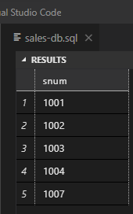

select distinct (snum) from orders;

Write a query that will give you all orders for more than Rs. 1,000

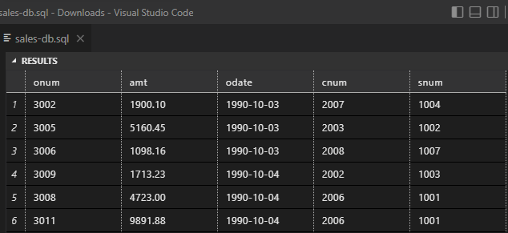

select * from orders where amt > 1000;

Write a query that will give you the names and cities of all salespeople in London with a commission above 0.10

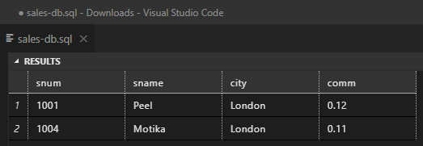

select * from salespeople where comm > 0.10 AND city = 'London';

***# Write a query on the Customers table whose output will exclude all customers with a rating <= 100, unless they are located in Rome***

What will be the output from the following query? Select * from Orders  
where (amt < 1000 OR  
NOT (odate = ‘1990-10-03’  
AND cnum > 2003));

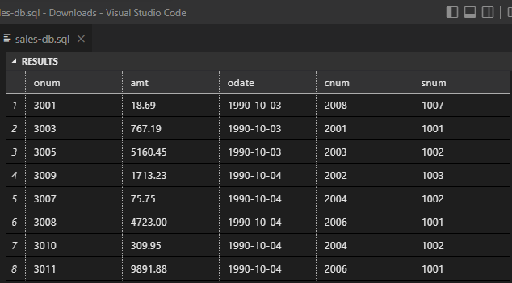

What will be the output of the following query?  
Select * from Orders  
where NOT ((odate = ‘1990-10-03’ OR snum >1006) AND amt >= 1500)



Write a query that selects all orders except those with zeroes or NULLs in the amt field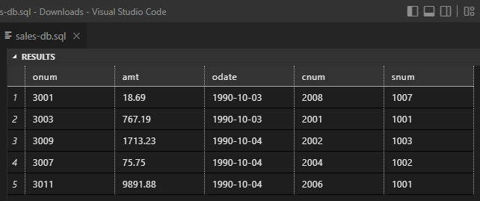

select * from orders where amt not LIKE '%0%' or amt <> null;